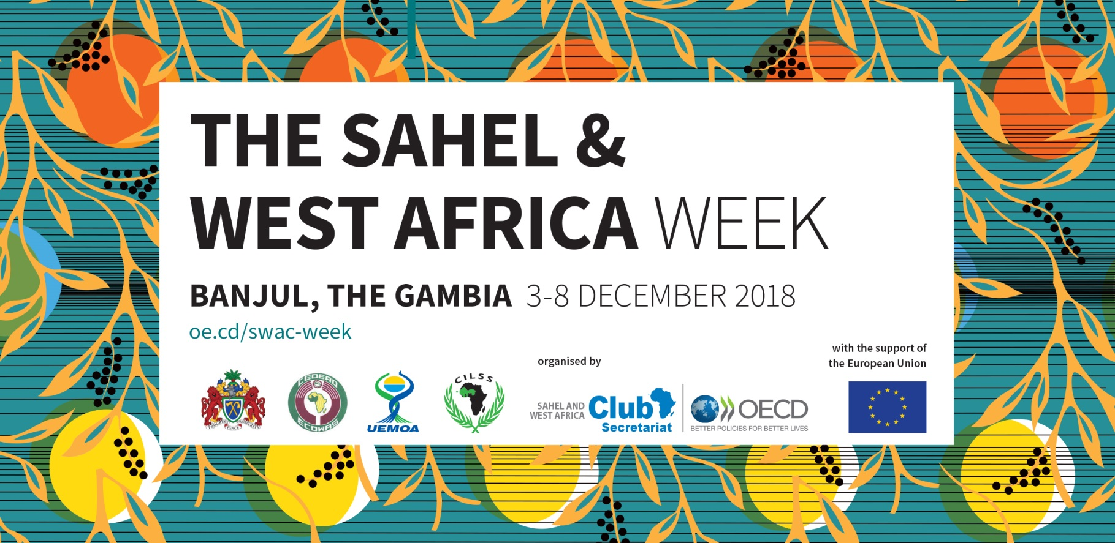

REGISTRATION FORM

Media Training Workshop
1 December 2018, Labranda Coral Beach Hotel, Room Bolunda 1

Please submit this form to: julia.wanjiru@oecd.org by 26 November 2018 latest
Places are limited and available on a first-come, first served basis.
Only accredited journalists will be allowed entry on site.

Your contact details
Name:
First name:
Title:
E-mail:
Twitter:
Facebook:
Phone:
Address:

Please also upload a recent ID picture (jpg) to put a face on your name.

Your professional interests

Media category:

TV
Radio
Print press
Online press
Social media

Current company

Academic background/Education

Thematic interests

References to relevant work (link to articles, stories, interviews)

Your motivation

Explain briefly, why you are interested in participating in this media training workshop?

What are your expectations?

Do you have any particular concerns or suggestions?

Your contribution for the practical exercises session

Share your work and make it visible.

The thematic session of the 34th annual meeting of the Food Crisis Prevention Network (RPCA) will focus on the topic of “Scaling-up best nutrition practices”. Drawing on your experience and previous work, please select one piece of your work (article, interview, video, blog, etc.) in relation to this topic and share it with us.

We will choose three samples for session 3 in the afternoon (see workshop agenda). The authors of the selected stories will be invited to present their work and will receive feedback from a professional media trainer and their peers. Make the best of this opportunity!

Your benefits

- You will be able to connect with a large number of development stakeholders in the Sahel and West Africa. The Week offers many opportunities for networking and building partnerships.
We invite you to make the most of it.
- You will benefit from media training and advice from media experts.
- You will be automatically registered as participant of the Sahel and West Africa Week and will thus be entitled to attend all events (with the exception of restricted events - see timeline).
You will receive the welcome package with key information and goodies of the Week.
- You will receive a USB key with documents and maps, sample copies of publications of the SWAC Secretariat, its members and stakeholders. Visit the Week’s document booth.
- You will be able to make your work visible. All articles, stories and interviews produced in relation to the Week will be valorised and published within the media report of the Sahel and West Africa Week on the OECD website. Please don’t forget to notify us.
Practical information and logistical arrangements

Labranda Coral Beach Hotel, Room Bolunda 1
Brufut Heights A. U Highway, Serrekunda, 0000 Brufut, The Gambia
Telephone: +220 441 0889
Site internet: gambiacoralbeach.com
Access: Only accredited journalists will be allowed entry on site. Follow the signage and present yourself directly at the Conference Centre. You will receive your badge at the welcome desk inside of the Conference Centre. The workshop will take place in Room Bolunda 1.

Meals: Workshop participants will be provided with coffee, beverages and a buffet lunch.
WIFI: A free access to Wifi connection will be provided by the hotel.
Local transport fees: Workshop participants will receive a lump sum to help them cover local transport fees. For logistical reasons, this lump sum will be paid on 5 December 2018, after the closing ceremony of the 34th RPCA annual meeting. More information will be provided during the media training workshop. Only participants of the media training workshop are eligible to receive this lump sum.
