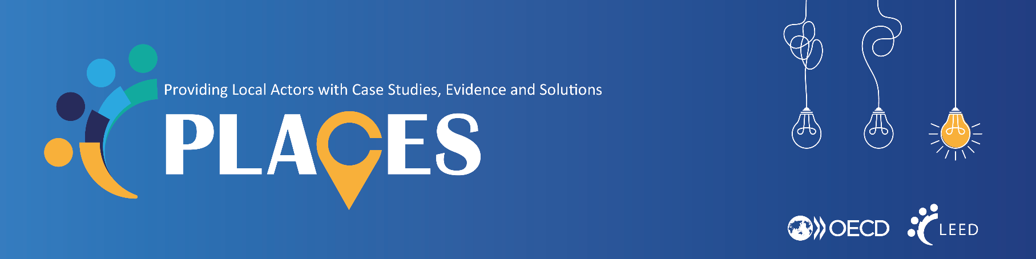
The OECD P.L.A.C.E.S. web portal
https://oecd.org/stories/local-development

As part of the OECD’s Local Development Forum, the new P.L.A.C.E.S. web portal is a searchable library of best practices from communities across the world, as well as policy briefs with the latest OECD evidence on key topics related to local development. For more information about the portal, check out this short video.
Help us expand this portal by contributing your own local case studies and best practices! We are particularly interested in case studies related to:
- Local employment and skills  - Economic and community development  - Social and solidarity economy | - SMEs and entrepreneurship  - Culture, creative sectors and hosting global events
We are looking for examples of local programmes, policies or initiatives that others across the world can learn from. We are particularly interested in those that:
- have a demonstrated successful impact (e.g. via a rigorous evaluation) or
- represent significant innovations or address new, emerging challenges, even if success has not yet been fully demonstrated.

Using the template on the next page, submit your example to the OECD Secretariat at Local.Forum@OECD.org. If it is a good fit for the portal, the Secretariat will work with you to finalise the case study before it goes live to the world. Have further questions? Don’t hesitate to reach out to Local.Forum@oecd.org.
Tips for drafting
- Put yourself in the mind of someone who knows little about your community or the programmes, policies or initiatives you are describing – what do they need to know to understand the context?
- Be as concrete as possible – how many people participated, what concretely changed, what was the role that each partner played, etc.
- Don’t be afraid to share what worked, and what didn’t! This portal is intended to be a platform for peer learning and exchange. Your story can help others avoid common pitfalls.
If you want to learn more about the work of the Local Development Forum and
be part of our community, sign up for our newsletter here.

TITLE
Key messages
- Please include 3 bullets indicating what you think are the most important takeaways from this example.

If

Visual: If you have an image you would like to use illustrate the project / initiative / policy, please share a high-resolution version with the OECD and indicate any copyrights.

What are the objectives?

1-2 paragraphs outlining briefly
- The local context for an international audience who may not be familiar with your community
- The problem the project / initiative / policy is trying to solve
- The goals of the project / initiative / policy

How does it work in practice?

3-4 paragraphs outlining as specifically how the project / initiative / policy works. Depending on the example, this may include
- Targeting and recruitment of participants
- Specific interventions delivered
- Development of new physical infrastructure or resources
- Partners engaged and their specific roles
- Specific policy / statutes that were changed
- Financing mechanisms

What has been the impact?
Include any evaluation evidence that demonstrates the impact of the project / initiative / policy. If none is available, please indicate how you intend to measure the impact / success of the programme.

What can other communities learn from this example?
Include 3-4 bullets on the key takeaways that may be transferrable to other communities wishing to implement a similar project / initiative / policy. Remember, others can learn as much from what did not work in your experience as what did work.

Further information
Include links to any further supporting materials about the programme, including in your own country language.

OECD resources
The OECD will complete this section

